Low Level Design

**NBA Draft Combine Measurement**

|  |  |
| --- | --- |
| **Written By** | Author 1, Author 2 |
| **Document Version** | 0.3 |
| **Last Revised Date** |  |

**DOCUMENT CONTROL**

### Change Record:

|  |  |  |  |
| --- | --- | --- | --- |
| **VERSION** | **DATE** | **AUTHOR** | **COMMENTS** |
| 0.1 | 15-July-2022 | Author 1 | Introduction and architecture defined |
| 0.2 | 18-July-2022 | Author 2 | Architecture & Architecture description appended and updated. |
|  |  |  |  |
|  |  |  |  |

### Reviews:

|  |  |  |  |
| --- | --- | --- | --- |
| **VERSION** | **DATE** | **REVIEWER** | **COMMENTS** |
| 0.2 | 22-July-2022 | Author 3 | Unit test cases to be added |

### Approval Status:

|  |  |  |  |  |  |
| --- | --- | --- | --- | --- | --- |
| **VERSION** | **REVIEW DATE** | **REVIEWED BY** |  | **APPROVED BY** | **COMMENTS** |
|  |  |  |  |  |  |

**Contents**

1. Introduction……………………………………………………………………………………03

##### 1.1 What is Low-Level Design Document? …………………………………………………….. 04

##### 1.2 Scope ……………………………………………………………………………………………………... 04

#### 2. Architecture ……………………………………………………………………………………………………….. 05

#### 3. Architecture Description …………………………………………………………………………………… 08

##### 3.1 Data Description ……………………………………………………………………………………… 08

##### 3.2 Web Scrapping ………………………………………………………………………………………… 08

##### 3.3 Data Transformation ……………………………………………………………………………… 08

##### 3.4 Data insertion into database …………………………………………………………………... 08

#### 4. Unit test cases ………………………………………………………………………………………………………15

# 1. Introduction

### 1.1 What is Low-Level design document?

The goal of the LDD or Low-level design document (LLDD) is to give the internal logic design of the actual program code for the House Price Prediction dashboard. LDD describes the class diagrams with the methods and relations between classes and programs specs. It describes the modules so that the programmer can directly code the program from the document.

### 1.2 Scope

Low-level design (LLD) is a component-level design process that follows a step-by-step refinement process. The process can be used for designing data structures, required software architecture, source code and ultimately, performance algorithms. Overall, the data organization may be defined during requirement analysis and then refined during data design work.

**2. Architecture**

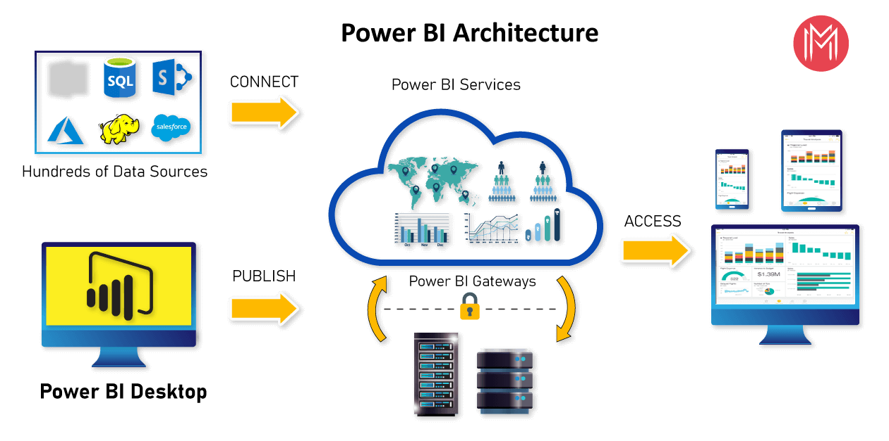

**PowerBi Server Architecture**

Power BI architecture is a service built on top of Azure. There are multiple data sources that Power BI can connect to. Power BI Desktop allows you to create reports and data visualizations on the dataset. Power BI gateway is connected to on-premise data sources to get continuous data for reporting and analytics. Power BI services refer to the cloud services that are used to publish Power BI reports and data visualizations. Using Power BI mobile apps, you can stay connected to their data from anywhere. Power BI apps are available for Windows, iOS, and Android platforms.

Tableau Server is internally managed by the multiple server processes.

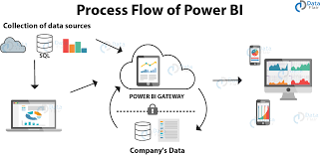

**1. Data Sources**

An important component of Power BI is its vast range of data sources. You can import data from files in your system, cloud-based online data sources or connect directly to live connections. If you import from data on-premise or online services there is a limit of 1 GB. Some commonly used data sources in Power BI are:

* Excel
* Text/CSV
* XML
* JSON
* Oracle Database
* IBM DB2 Database

### 2) PowerBi Desktop:-

|  |
| --- |
| Power BI Desktop is a client-side tool known as a companion development and authoring tool. This desktop-based software is loaded with tools and functionalities to connect to data sources, transform data, data modeling and creating reports.   1. **PowerBi Server:-**   The Power BI Report Server is similar to the Power BI Service. The only difference between these two is that Power BI Report Server is an on-premise platform. It is used by organizations who do not want to publish their reports on the cloud and are concerned about the security of their data.   1. **PowerBi Gateway:-** |

This component is used to connect and access on-premise data in secured networks. Power BI Gateways are generally used in organizations where data is kept in security and watch. Gateways help to extract out such data through secure channels to Power BI platforms for analysis and reporting.

### 5) PowerBi Mobile:-

Power BI Mobile is a native Power BI application that runs on iOS, Android, and Windows mobile devices. For viewing reports and dashboards, these applications are used.

### 6) PowerBi Embedded:-

### Power BI Embedded offers APIs which are used to embed visuals into custom applications.

**3. Architecture Description**

### 3.1. Data Description

The Dataset contains house price of cities that fall under the categories A,B and C based on the availability of parking, rainfall, its built-up area etc

1. Dist_Taxi: Distance to nearest taxi stand from the property (in metres).
2. Dist_Market: Distance to nearest grocery market from the property (in metres).
3. Dist_Hospital: Distance to nearest hospital from the property (in metres).
4. Carpet: Carpet area of the property in square feet (in square ft.)
5. Built-up: Built-up area of the property in square feet (in square ft.)
6. Parking: Type of car parking available with the property
7. City_Category: Categorization of the city based on the size
8. Rainfall: Annual rainfall in the area where property is located (in cm) 9. House_Price: Price at which the property was sold (in Dollars)

### 3.2. Web Scrapping

Web scraping is a technique to automatically extract content and data from websites using bots. It is also known as web data extraction or web harvesting. Web scrapping is made simple now days, many tools are used for web scrapping. Some of python libraries used for web scrapping are Beautiful Soup, Scrapy, Selenium, etc.

### 3.3. Data Transformation

In the Transformation Process, we will convert our original datasets with other necessary attributes format. And will merge it with the Scrapped dataset.

### 3.4. Data Insertion into Database

1. Database Creation and connection - Create a database with name passed. If the database is already created, open the connection to the database.
2. Table creation in the database.
3. Insertion of files in the table

\

## 3.5. Export Data from Database

Data Export from Database - The data in a stored database is exported as a CSV file to be used for Data Pre-processing.

**4. Unit Test Cases**

|  |  |
| --- | --- |
| **TEST CASE DESCRIPTION** | **EXPECTED RESULTS** |
| Year | When clicked on the slicer, a dropdown should occur which has various parameters of the Year. |
| Count of Players | When clicked on the Card, a count of Player should occur which describes the count of the Player. |
| Detail Between Year and player | Here a tables is shown which shows the details between year and the player. |
| Average of shoes(with shoes) and Average of shoes(without shoes) by year | Here a line chart is shown which shows the Average of shoes(with shoes) and Average of shoes(without shoes) by year |
| Count of hand(length) and count of hand(width) by year | Here a line chart is shown which shows the Count of hand (length) and count of hand (width) by year. |
| Count of vertical(no step reach) and count of vertical(step) by year | Count of vertical (no step reach) and count of vertical (step) by year here a line chart is shown which shows the Count of hand (length) and count of hand (width) by year. |
| Count of weight by year | Count of weight by year is shown which shows the Count of hand (length) and count of hand (width) by year. |
| Height(with shoes) and weight by year | Here a line chart is shown which shows the scatter plot between  Height (with shoes) and weight by year. |
| Player Details | A table is shown which shows player details. |
| Average of body fat by year | A line chart which shows average of body fat by year |